**Parameters under Variation**: In this simulation of wireless 802.15 number of flow, packet per second, speed of node and coverage area are taken constant and values are respectively 10,100,5,1. The parameter that have been changed is number of node. Number of node are changed from 20 to 100 at a rate 20.

**Modification made in the simulator:**

1.By default hello packet are disabled in AODV protocol. In this simulation Hello packet are enabled.

2.Unreliable source expire time reduced. A source which was down before but now up is considered as an unreliable source.SO its expire time is reduced to 40%.

3.Adding field in AODV class and forwarding logic in sendRequest() method according to paper “Congestion Control Modified AODV(MAODV)” by Rijutha Dalta,Yefa Mei, Dr.NanWang.

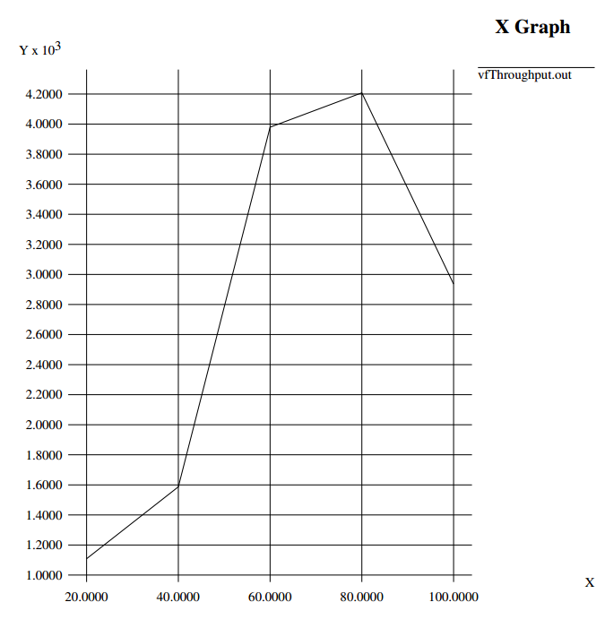

Fig. Throughput -Node inWireless802.15mobile(Before).

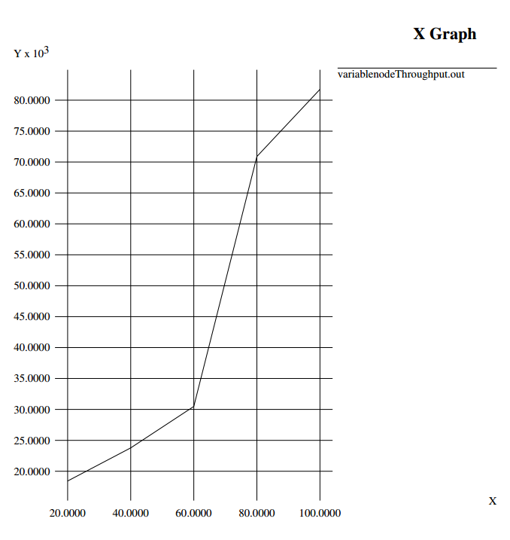 Fig.Throughput -Node inWireless802.15mobile(After).

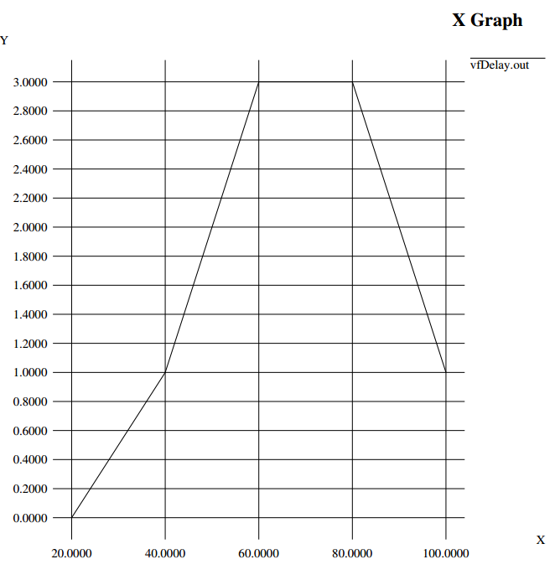

Fig. Delay -Node inWireless802.15mobile(Before).

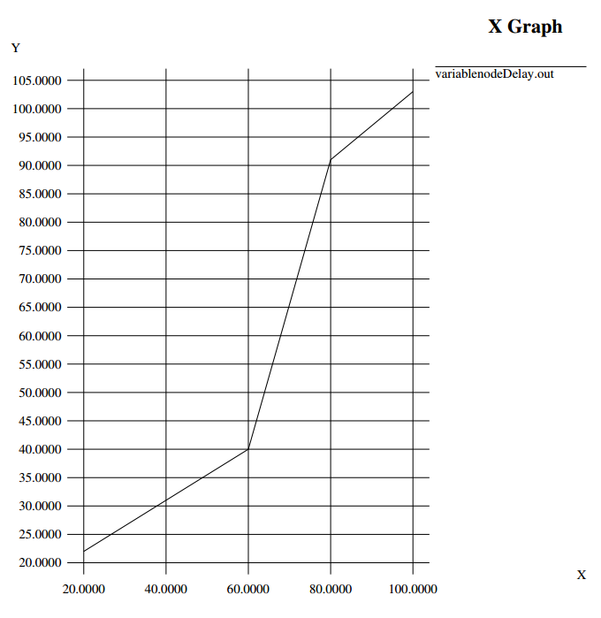

Fig. Delay -Node inWireless802.15mobile(After).

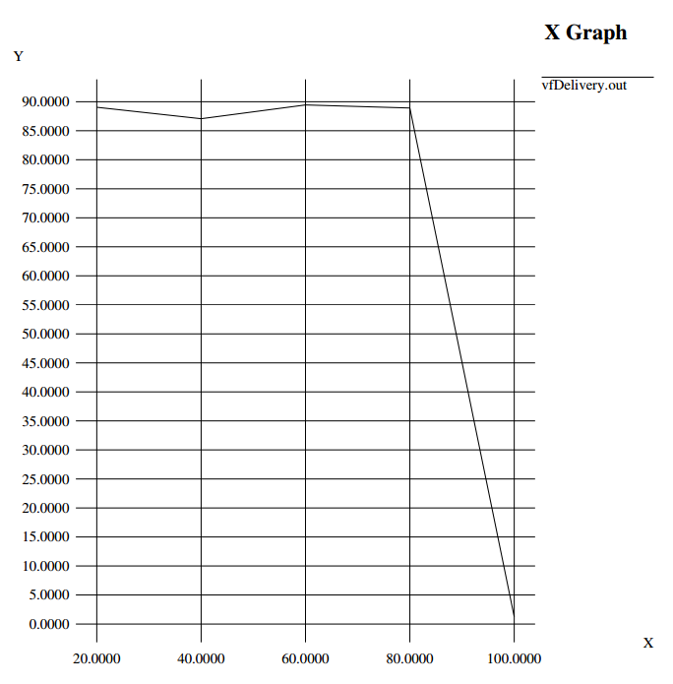

Fig. Deliveryratio -Node inWireless802.15mobile(Before).

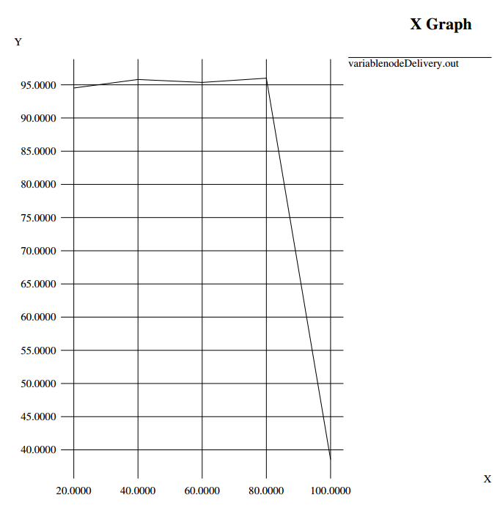

Fig. DeliveryRatio -Node inWireless802.15mobile(After).

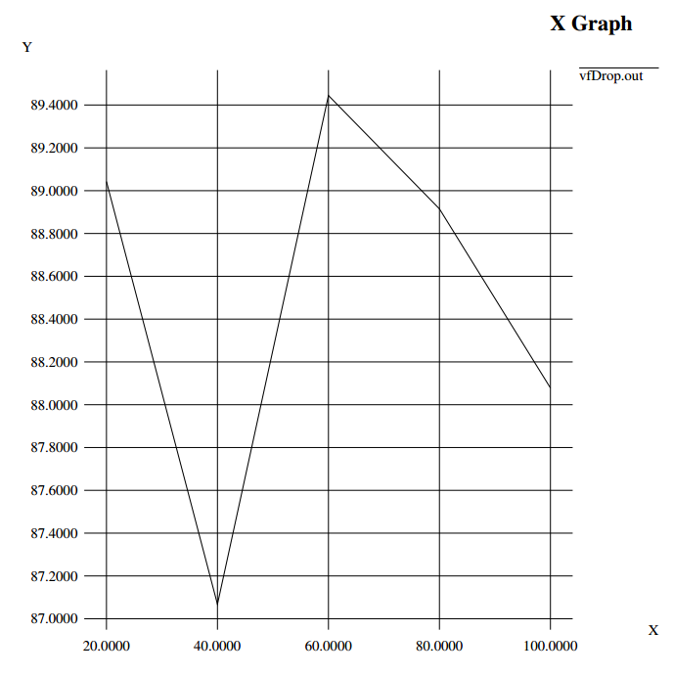

Fig.DropRatio -Node inWireless802.15mobile(Before).

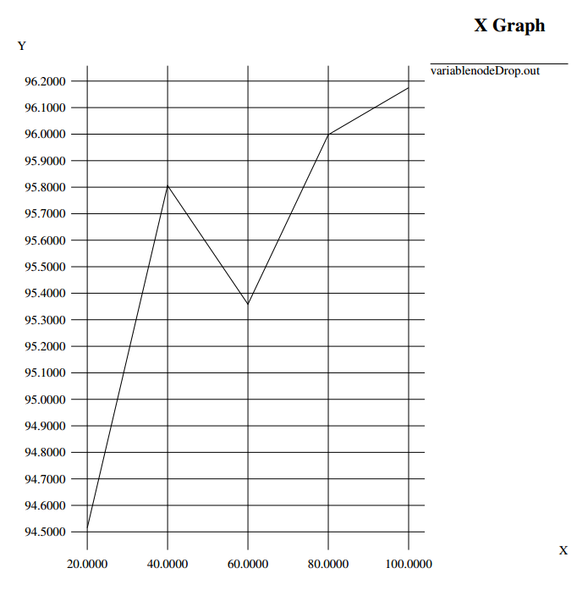

Fig. DropRatio -Node inWireless802.15mobile(After).

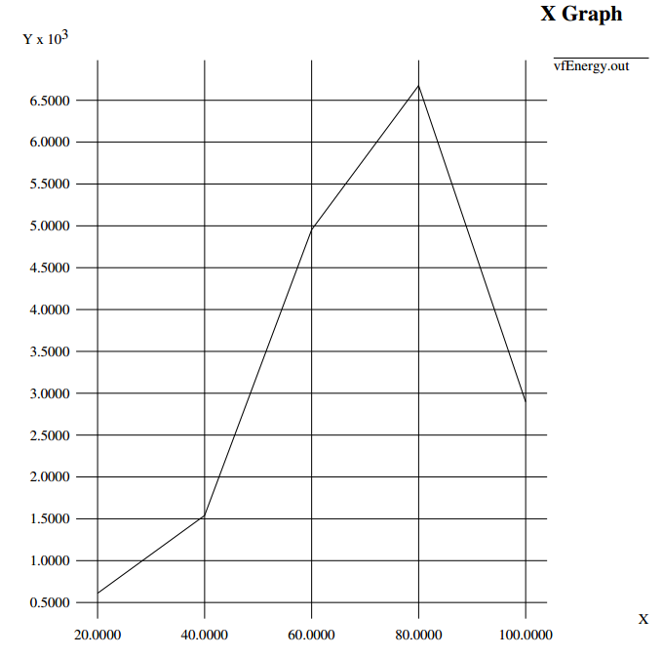

Fig. Energy -Node inWireless802.15mobile(Before).

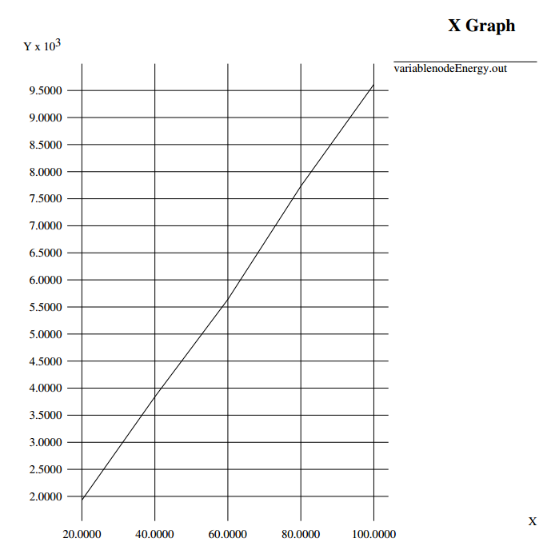

Fig. Energy-Node inWireless802.15mobile(After).

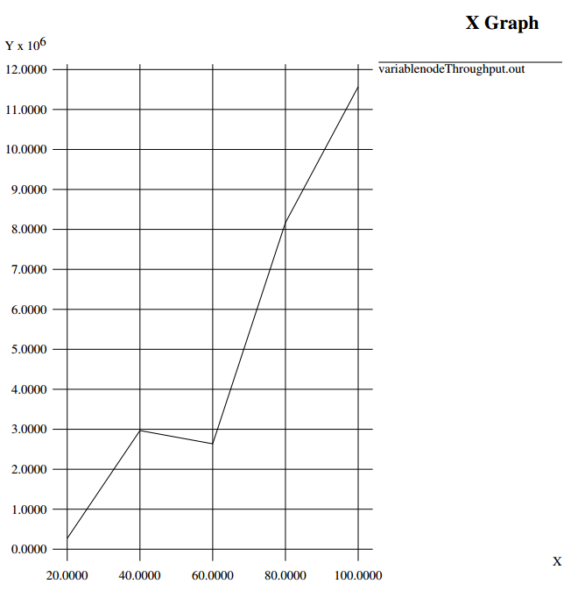

Fig. Throughput-Node inWirelss802.11Static(Before).

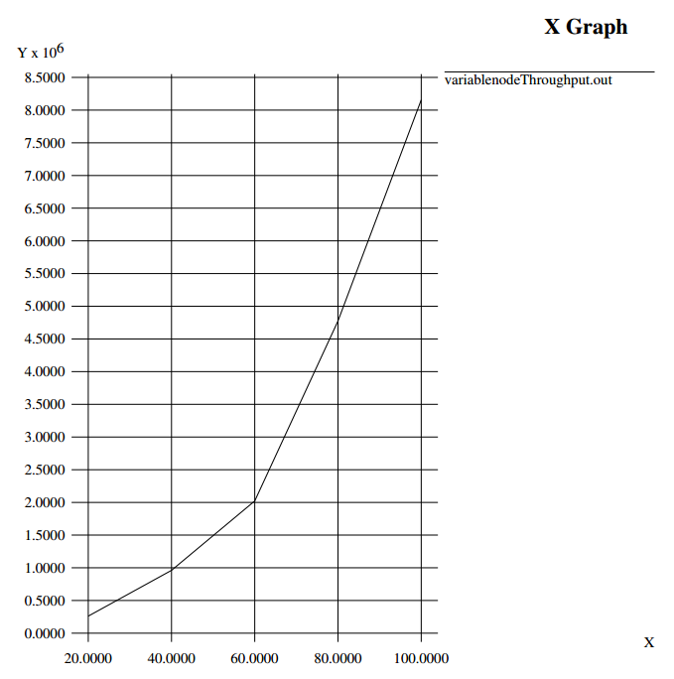

Fig. Throughput-Node inWirelss802.11Static(After).

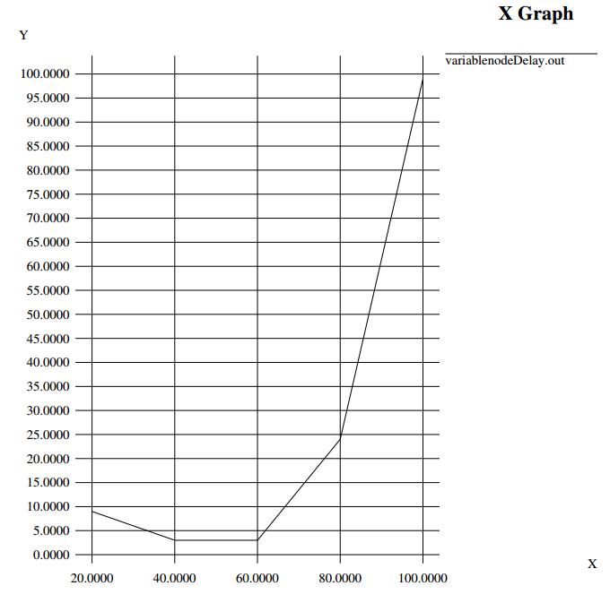

Fig. Delay-Node inWirelss802.11Static(Before).

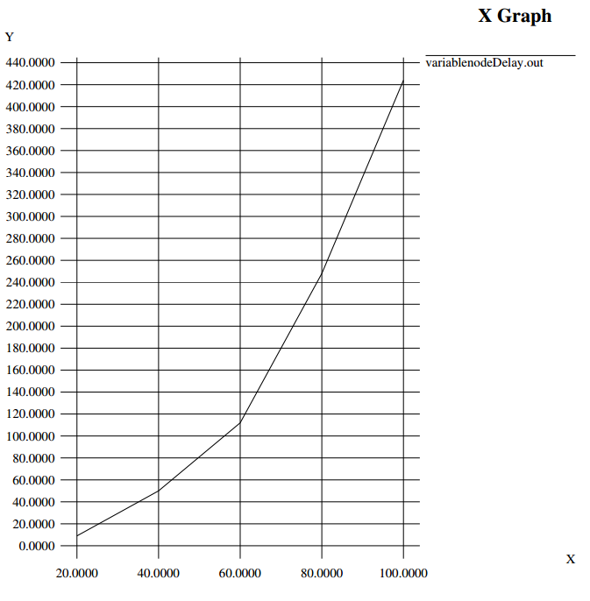

Fig. Delay-Node inWirelss802.11Static(After).

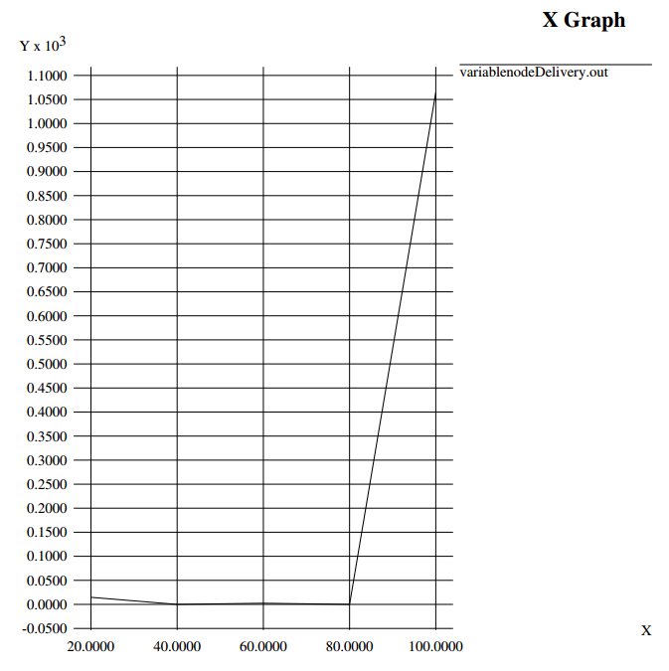

Fig. DeliveryRatio-Node inWirelss802.11Static(Before).

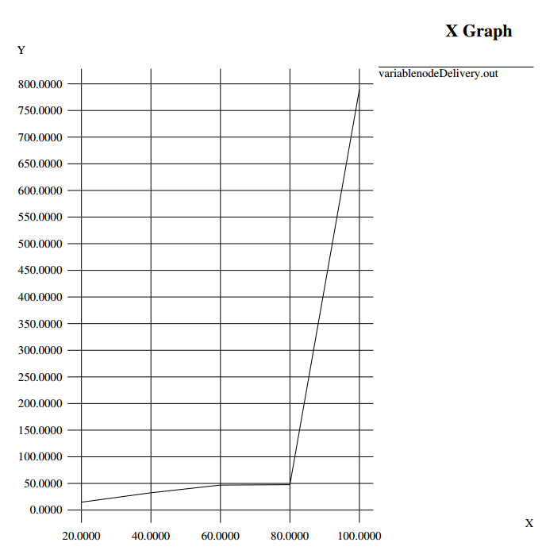

Fig. DeliveryRatio-Node inWirelss802.11Static(After).

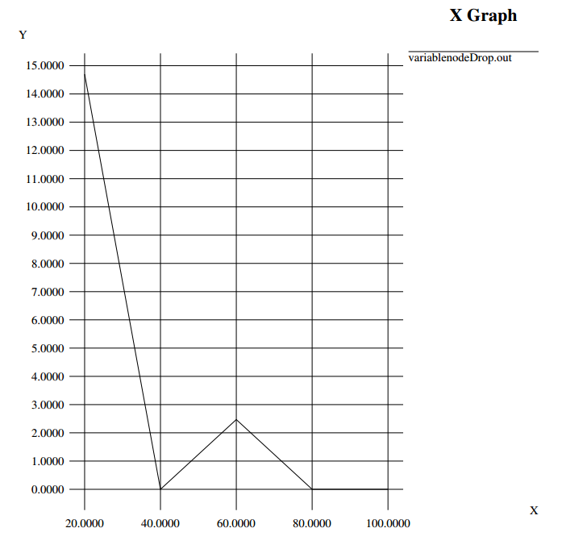

Fig. DropRatioNode inWirelss802.11Static(Before).

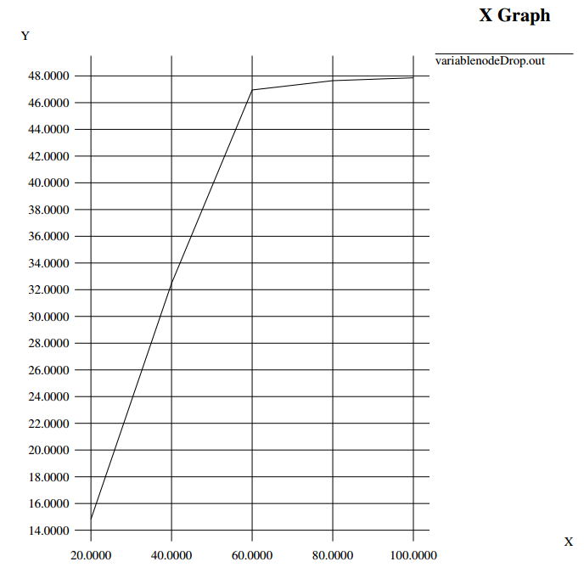

Fig. DropRatio-Node inWirelss802.11Static(After).

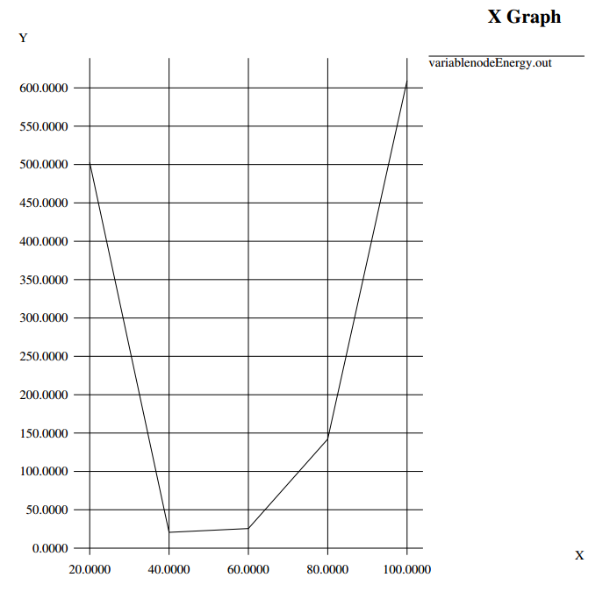

Fig. Energy-Node inWirelss802.11Static(Before).

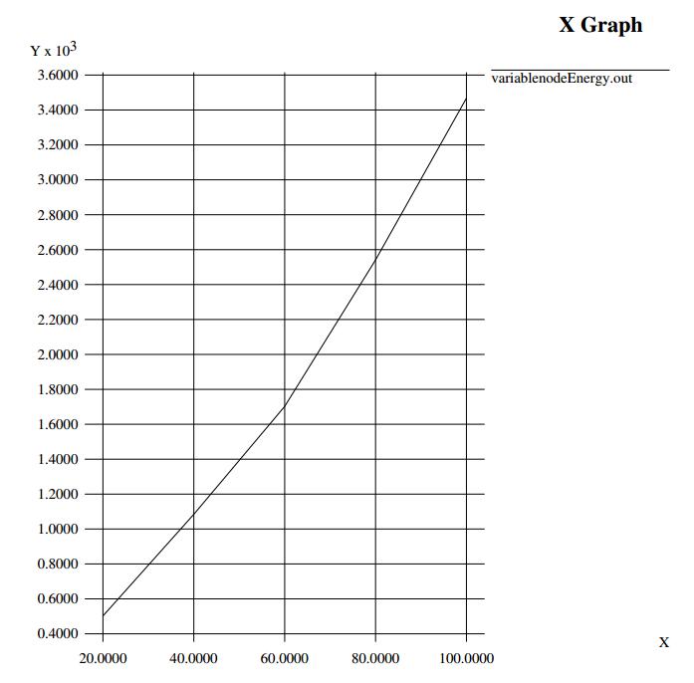

Fig. Energy-Node inWirelss802.11Static(After).